Registration of a data repository/archive/service in the TOAR data portal

The TOAR data portal at https://toar-data.org shall provide an easily accessible overview about data collections of tropospheric ozone around the world. Each entry in the TOAR data portal consists of several elements:
(Example)
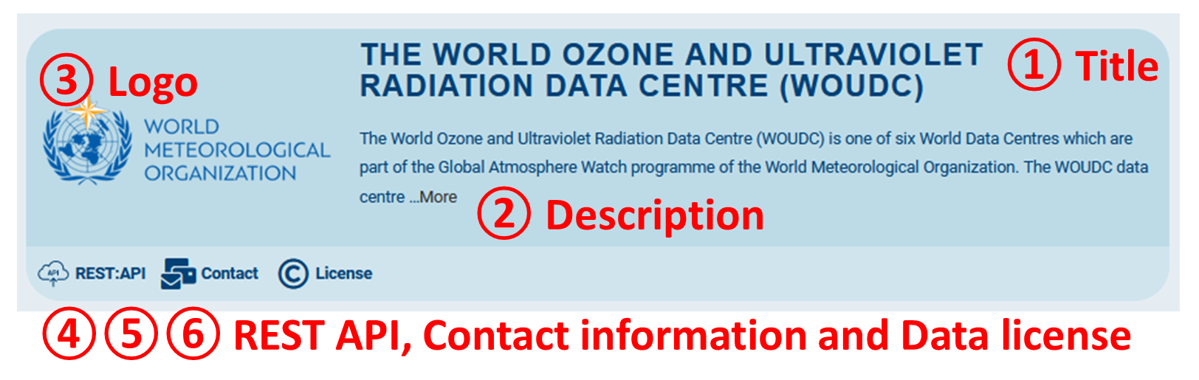

The following information can be submitted either via this form or in an email to a.mozaffari@fz-juelich.de. Please make sure to use the numbers as shown above to identify the individual elements of a new entry. Logos can be sent in any graphics format – Amirpasha will contact you if there are any issues with the data you send.

① Title: please provide a string of max 60 characters to identify the data centre/repository/collection *AND* provide the URL (= web address) which brings users as close to the data as possible.
Title string:
URL:

② Description: please provide a URL pointing to the web page which best described the dataset/collection/repository. Usually we will then use the first 2 or 3 sentences from that web page as teaser text. If we should use a different teaser text, please enter it below.
URL:
Teaser text (optional):
③ Logo: please provide an image file with sufficient resolution (minimum 200 x 200 pixels), or preferably a vector graphics format (e.g. SVG or PNG)

④ REST API: if your data centre/repository features a REST API, then please enter the URL below. Typically, this “entry URL” would point to a page describing the REST API. Often this is done through automated documentation, for example with Swagger. If you don’t know what a REST API is, then simply leave this field empty.
URL:
⑤ Contact information: please provide a URL which displays contact information for your data centre/repository, or an email address if the contact information is not displayed prominently on a separate web page.
URL or email address:

⑥ Data license: please provide a URL which shows the data use conditions or license of your data centre/repository. If this is not clearly documented on your web pages (or hidden somewhere within a longer text), then please enter the data license model you follow. Please note that TOAR is all about open data sharing. Therefore, we encourage you to choose a license with as little restrictions as possible. Our standard in TOAR is “Creative Commons by attribution” (CC-BY4.0).
URL or license model:

⓪ Finally, please provide your name, institution and email address in case we need to contact you again:
Name:
Institute:
Email:

