Registration of a data repository/archive/service in the TOAR data portal
The TOAR data portal shall provide an easily accessible overview about data collections of tropospheric ozone around the world. Each entry in the TOAR data portal consists of several elements:
(Example)
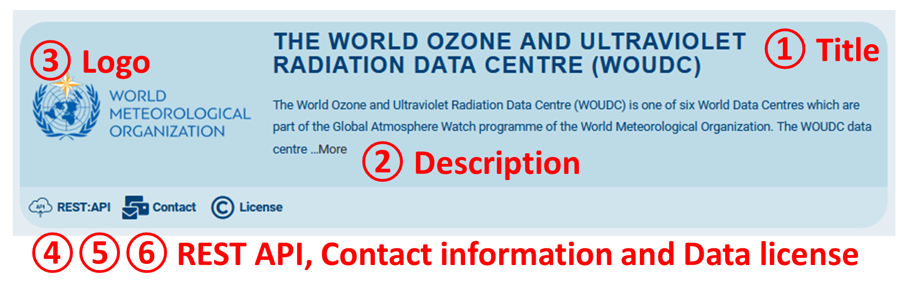
1. Title: Repository Name and Dataset URL
Provide:
- A short name identifying the repository, archive, or data service (max 60 characters).
- The URL that brings users as close to the data as possible.
Example
Repository Name: NASA OMI Tropospheric Ozone Product
Dataset URL: https://example.org/data
2. Repository Description
Provide either:
- The URL of the webpage that best describes the repository, or
- Summary text if you would like TOAR to display a specific description.
3. Repository Logo (Optional)
Provide a logo representing the repository or organization.
Recommended formats:
- SVG
- PNG
Recommended minimum size:
- 200 × 200 pixels
4. REST API (Optional)
If machine-readable access is available, provide the URL of the API documentation or entry point.
If no API exists, leave this information blank.
5. Contact Information
Provide either:
- An email address, or
- A URL containing contact information for the repository.
6. Data License
Provide:
- A URL describing the license, or
- The license name if no dedicated webpage exists.
TOAR encourages the use of open licenses such as Creative Commons Attribution (CC BY 4.0) whenever possible.

The following form can be used as an alternative to the online repository registration form available at TOAR Data Portal.
Please complete the fields below and return the form to support@toar-data.org. This form may also be used to:
- Register a new repository or data service
- Request updates to an existing TOAR entry
- Report errors in an existing TOAR entry

Submitter Information
Name: ______________________________________
Email: ______________________________________

Repository Information
1. Data Category
Please select the category that best describes the data source:
☐ Satellite
☐ Surface
☐ Sonde & Lidar
☐ Aircraft
☐ Model Data
☐ Other: _______________________

2. Repository Name
Provide a concise name for the repository, archive, or data service.
Repository Name: ______________________________________

3. Repository Description
Provide a brief description of the repository and the data it contains.
Description:
____________________________________________________________________________________________________________________________________________________________________________________________________________________________________________________________________________________________________________________________________________________________________

4. Repository Logo (Optional)
Provide a logo representing the repository or organization.
Preferred formats: SVG or PNG.
Logo file attached: ☐ Yes ☐ No

5. Dataset URL
Provide the URL that brings users as close to the data as possible.
URL:
_________________________________________________________________________________________

6. Repository Description URL
Provide the URL of the webpage that best describes the repository.
URL:
_________________________________________________________________________________________

7. REST API (Optional)
If machine-readable access is available, provide the URL of the API documentation or entry point.
REST API URL:
_________________________________________________________________________________________

8. Curator Contact Information
Provide either an email address or a URL to a contact page.
Email or URL:
_________________________________________________________________________________________

9. Data License
Provide either a URL describing the data license or the name of the license.
Examples
- CC BY 4.0
- CC BY-SA 4.0
- URL to license page
License information:
_________________________________________________________________________________________

10. Comments (Optional)
Use this section for additional information, update requests, or notes for the TOAR team.
____________________________________________________________________________________________________________________________________________________________________________________________________________________________________________________________________________________________________________________________________________________________________

Submission Type
☐ New repository registration
☐ Update to an existing TOAR entry
☐ Correction of an existing TOAR entry

